**Shri G.S. Institute of Technology and Science**

**INODRE**

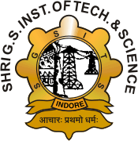

**Department of Applied Mathematics & Computational Science**

**MCA First Year Semester I July-December 2024**

**Lab Assignment**

**MA 10210: STATISTICAL COMPUTING TECHNIQUES**

SUBMITED TO SUBMITTED BY

Dr. Deepti Mokati SHIV ARORA

Ms. Payal Khandelwal Enrolment No.

0801CA241133